**Student: Hitesh Manglani Assignment III Due date: 1:00PM 4/18/2020**

1. **A major newspaper is considering to launch an online edition. The newspaper plans to go ahead only if at least 30% of current readers would subscribe. The newspaper surveyed a random sample of 400 current readers, and 130 of those express interest.**
2. **What should the newspaper do? Use appropriate test and state the assumption(s).**
3. **What is the P-value for the test you have conducted in part a**
4. The newspaper should conduct a one tailed hypothesis test for the proportion of readers that will subscribe to the online edition

1.Value of Interest: Proportion of current readers = p̂

2.Null Hypothesis: p̂  >= 0.3

Alternative: p̂  < 0.3

3.Desired level of significance is 0.05 (industry/academic standard)

4.Rejection Region:

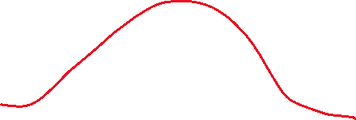

5. Check assumptions and compute

Check 400 x .325 = 130

400 x .675 = 270 . SRS condition is satisfied

Compute the Z test statistic

Z = (p̂ -p0) / (sq. root ((p0 (1-p0))/n)))

P ( p̂ < 0.3 ) = P ( Z < (p̂ -p0) / (sq. root ((p0 (1-p0))/n))) )

p0  from sample = 130/400 = 0.3250

z = (0.325 – 0.3) / (sqrt ((0.325)(0.675))/400) = .025/ .0234 = 1.0675

6.Make decision/Interpret results: The observed z is 1.0675 whereas as the critical z value is -.1645

We do not reject the hypothesis that at least 30% users will subscribe. We can launch the online edition.

b) Find the observed p value or the lowest significance level for which H0 may be rejected by the data

From (a) we computed observed z as 1.0675. The area to the left of this z value from the graph is 0.1423

This observed level of significance aka P value is 0.1423 > 0.05 , so we do not reject H0

1. A company that produces cell phone batteries claims their new battery last more than 30 hours.

To investigate this claim a consumer advocacy group collected the following random sample for number hours that each battery worked:

50, 40, 35, 25, 60, 55, 30, 50, 30, 20

Is there a sufficient evidence to accept the company’s claims using 0.01 significance level?

N =10

Mean =. 041.667

S =12.5

1. We are interested to test for µ
2. State test

Null hypothesis : mean µ ≤ 30 : The battery lasts 30 hours or less on average

Alternative Hypothesis : µ > 30 : The battery lasts more than 30 hours

1. Desired α =.01
2. Rejection region



Use t statistic



Dof 9

2.821

If computed t stat is greater than 2.821 reject null



5. Compute the statistic

(41.667-30)/((12.5/sqrt(30))

t=5.1122

6. Make decision and Interpret : Calculated t > 2.821 . Reject null hypothesis

Yes there is sufficient evidence for the company’s claim at the 0.0qq1 significance level

3.

The main access road to a suburban shopping mall sometimes becomes severely congested. On weekdays, excluding holidays, the average number of vehicles going toward the mall between 9 A.M. and 7 P.M. that pass a counter is 13,260. The highway department tried to improve traffic flow by changing stoplight cycles and improving turn lanes. For the first seven non holiday weekdays after the changes, the volumes were 10,690, 11,452, 12,316, 12,297, 13,089, 11,995,  
and 12,647. A local politician who reviewed the sample results said that the data proved there had been no improvement in traffic volume. Using a 0.05 significance level Do you think is there a sufficient evidence to accept the politician’s interpretation?

**No there is not sufficient evidence to agree with politician**

**Test**

|  |  |  |  |
| --- | --- | --- | --- |
| Null hypothesis | | | H₀: μ = 13260 |
| Alternative hypothesis | | | H₁: μ < 13260 |
| **T-Value** | **P-Value** |
| -3.97 | 0.004 |

**Descriptive Statistics**

|  |  |  |  |  |
| --- | --- | --- | --- | --- |
| **N** | **Mean** | **StDev** | **SE Mean** | **95% Upper Bound for μ** |
| 7 | 12069 | 793 | 300 | 12652 |

*μ: mean of C2*

At the 0.05 significance level we reject the null hypothesis that there is no change/improvement.

Use MINITAB data file is posted on NYU classes.

The data in Used cars data file indicate the prices of 115 used BMW cars. Some have four-wheel drive (the model identified by the Xi type and the others two-wheel drive (the model denoted by the letter I). If we treat data as sample of the typical selling prices of these models, what do you conclude? Do four-wheel drive models command a higher price as two wheel drive, or not?

Use α = 0.1.

***I conclude that the four wheel drive models command a higher price.***

I used the boxplots analysis to assume equal variance

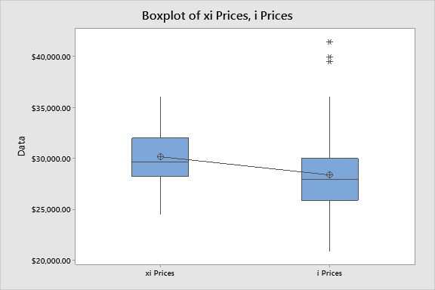

**Method**

|  |
| --- |
| μ₁: mean of xi Prices |
| µ₂: mean of i Prices |
| Difference: μ₁ - µ₂ |

*Equal variances are assumed for this analysis.*

**Test**

|  |  |  |  |  |
| --- | --- | --- | --- | --- |
| Null hypothesis | | | H₀: μ₁ - µ₂ = 0 | |
| Alternative hypothesis | | | H₁: μ₁ - µ₂ ≠ 0 | |
| **T-Value** | **DF** | **P-Value** | |
| 2.58 | 113 | 0.011 | |
|  |  |  | |

**Estimation for Difference**

|  |  |  |
| --- | --- | --- |
| **Difference** | **Pooled StDev** | **90% CI for Difference** |
| 1794 | 3627 | (640, 2948) |

I reject the null hypothesis and conclude that four wheel drive models do seem to command a higher price***, note that I am not taking into account the model year of the car in my analysis (the relative depreciation over time is not being taken into account)***

5.

A regional automotive parts chain store firm wants to improve the sales of tune- up supplies. It believes that a TV ad with a popular local, but offbeat, know-it-all actor might be able to affect their sales. Before the ads are run on TV, the company randomly samples eight of its weekly sales from the past years. Following the ad campaign, seven weeks of sales were sampled. Weekly sales are approximately normally distributed and the population standard deviations are equal. Their hypothesis test is: Did the TV ad campaign help sales?

To answer this question, the company plans to use a 0.05 significance level. The results of the two samples are:

Before Ad Campaign After Ad campaign

= 8 = 7

 = 174  = 189

= 484  = 400

Did the ad campaign help sales?

Ho : µy2 - µy1 ≤ 0

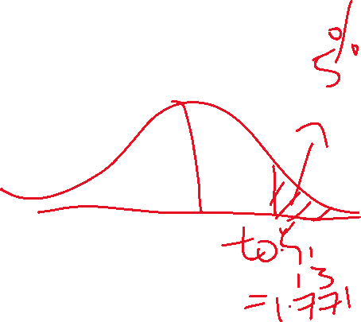

Ha : µy2 - µy1 > 0

t α at 13 dof = 1.771 ( 13 dof , .05)

Reject if t> 2.160

S(p) = sqrt [( ( n1 – 1) (s1^2 ) + (n2 -1) (s2^2) ) / n1+n2-2)

= 21.1005

t = ( (y2 – y1) – 0) / ( s(p) * sqrt ( 1/ 7 + 1/8) ) = 1.3736

calculated t ≤ t α

WE do not reject Ho

We cannot conclude that the ad campaign helped sales.

A regulatory agency is investigating an advertisement that a new device will increase the mileage of the cars. Six such devices are installed in six cars. The Gasoline mileage for each of the cars are recorded both before and after installation.

|  |  |  |  |  |
| --- | --- | --- | --- | --- |
| Car | MGP before | MGP after | d | d 2 |
| 1 | 19.1 | 22.1 | 3 | 9 |
| 2 | 35 | 35 | 0 | 0 |
| 3 | 25.3 | 21.3 | -4 | 16 |
| 4 | 29.5 | 37.5 | 8 | 64 |
| 5 | 31.8 | 34.8 | 3 | 9 |
| 6 | 35 | 40 | 5  Sum = 15 | 25 |
|  |  |  | Mean = 2.5 | 123.0 |

Is the advertised claim supported at α =0.10?

Let d = MGP after - MGP before

Ho = µd ≤ 0 (i.e the new device does not increase the mileage)

Ha = µd > 0 (i.e the new device increased the mileage)

Dof = 5

t α = 2.015

Reject the H o it t calculated > 2.015

Sd = sqrt ( ( Sumd2 – ((Sumd)^2/n) ) /n-1 ) = 4.1352

T calculated = dhat - µ / ( Sd/sqrt (n))

= 2.5/1.6882

= 1.4809

WE do not reject the Ho

We conclude there is some evidence that the new device increased the mileage

There could be lurking variables, ie were the road driving conditions, tires, etc etc the same? Ideally it should be a randomized test